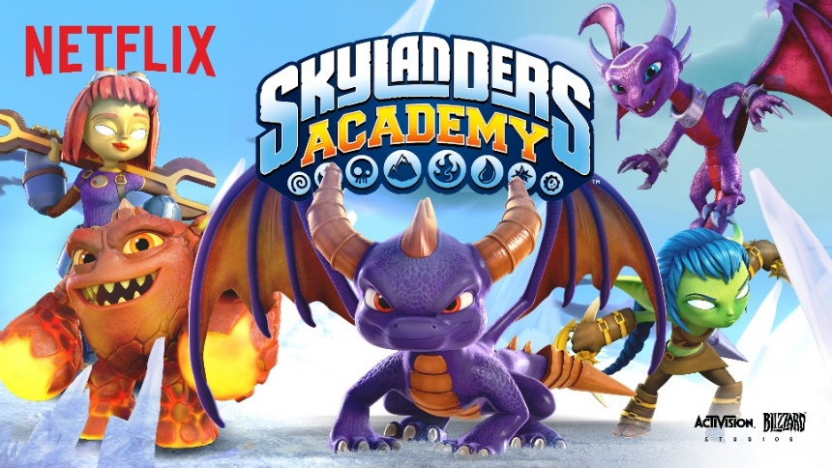

Halloween is two weeks away! Can you believe it? Do you have your costumes picked out already? My kids love the Netflix series SkylandersTM Academy, and there is a really cute Halloween safety tips video made by the folks behind the series that would be great to watch on Halloween before heading out for trick-or-treating. Check it out below to see how the Skylanders are keeping it safe this Halloween.

https://www.youtube.com/watch?v=QWXv1LhuKII&t=8s
<iframe width="560" height="315" src="https://www.youtube.com/embed/QWXv1LhuKII" frameborder="0" allowfullscreen></iframe>

I’ve actually partnered with Activision Blizzard Studios, the studio behind Skylanders Academy, to host a Halloween costume contest. The one (1) winner will receive a PlayStation 4 console and a Skylanders Imaginators Starter Pack for PS4 videogame. As the Skylanders are taking over the IHOP® kids menus during the month of October, two (2) runners-up in the contest will receive a $50 IHOP gift card.
Starting now and through Wednesday, November 1st, you can upload a picture of your homemade costume, your kids’ costume or your family’s Halloween costume to either Twitter or Instagram with the hashtag: #SkylandersAcademyCostumeContest and then post a link in the Comments section below to your tweet or Instagram post. Please make sure that you use your own personal Twitter or Instagram account and that your tweet or post is public.
The costume can be of anything or anyone – not just Skylanders characters. But it needs to be a somewhat homemade, and not completely a store-bought costume. I want to see some creativity! Of course, some pieces may be purchased, but fully packaged costumes will not be considered.
I’m working with Angela Sellari / Caryn Bailey from the wonderful blog About A Mom / Rockin’ Mama – and together we will choose and announce the winner and runners-up across both of our blogs on Monday, November 6th.
Contest entry is restricted to residents of the 48 contiguous United States and the District of Columbia only and you must be over the age of 18 years old at the time of entry. Bloggers and non-bloggers may enter. Please see the Official Skylanders Academy Halloween Costume Contest Rules here.

